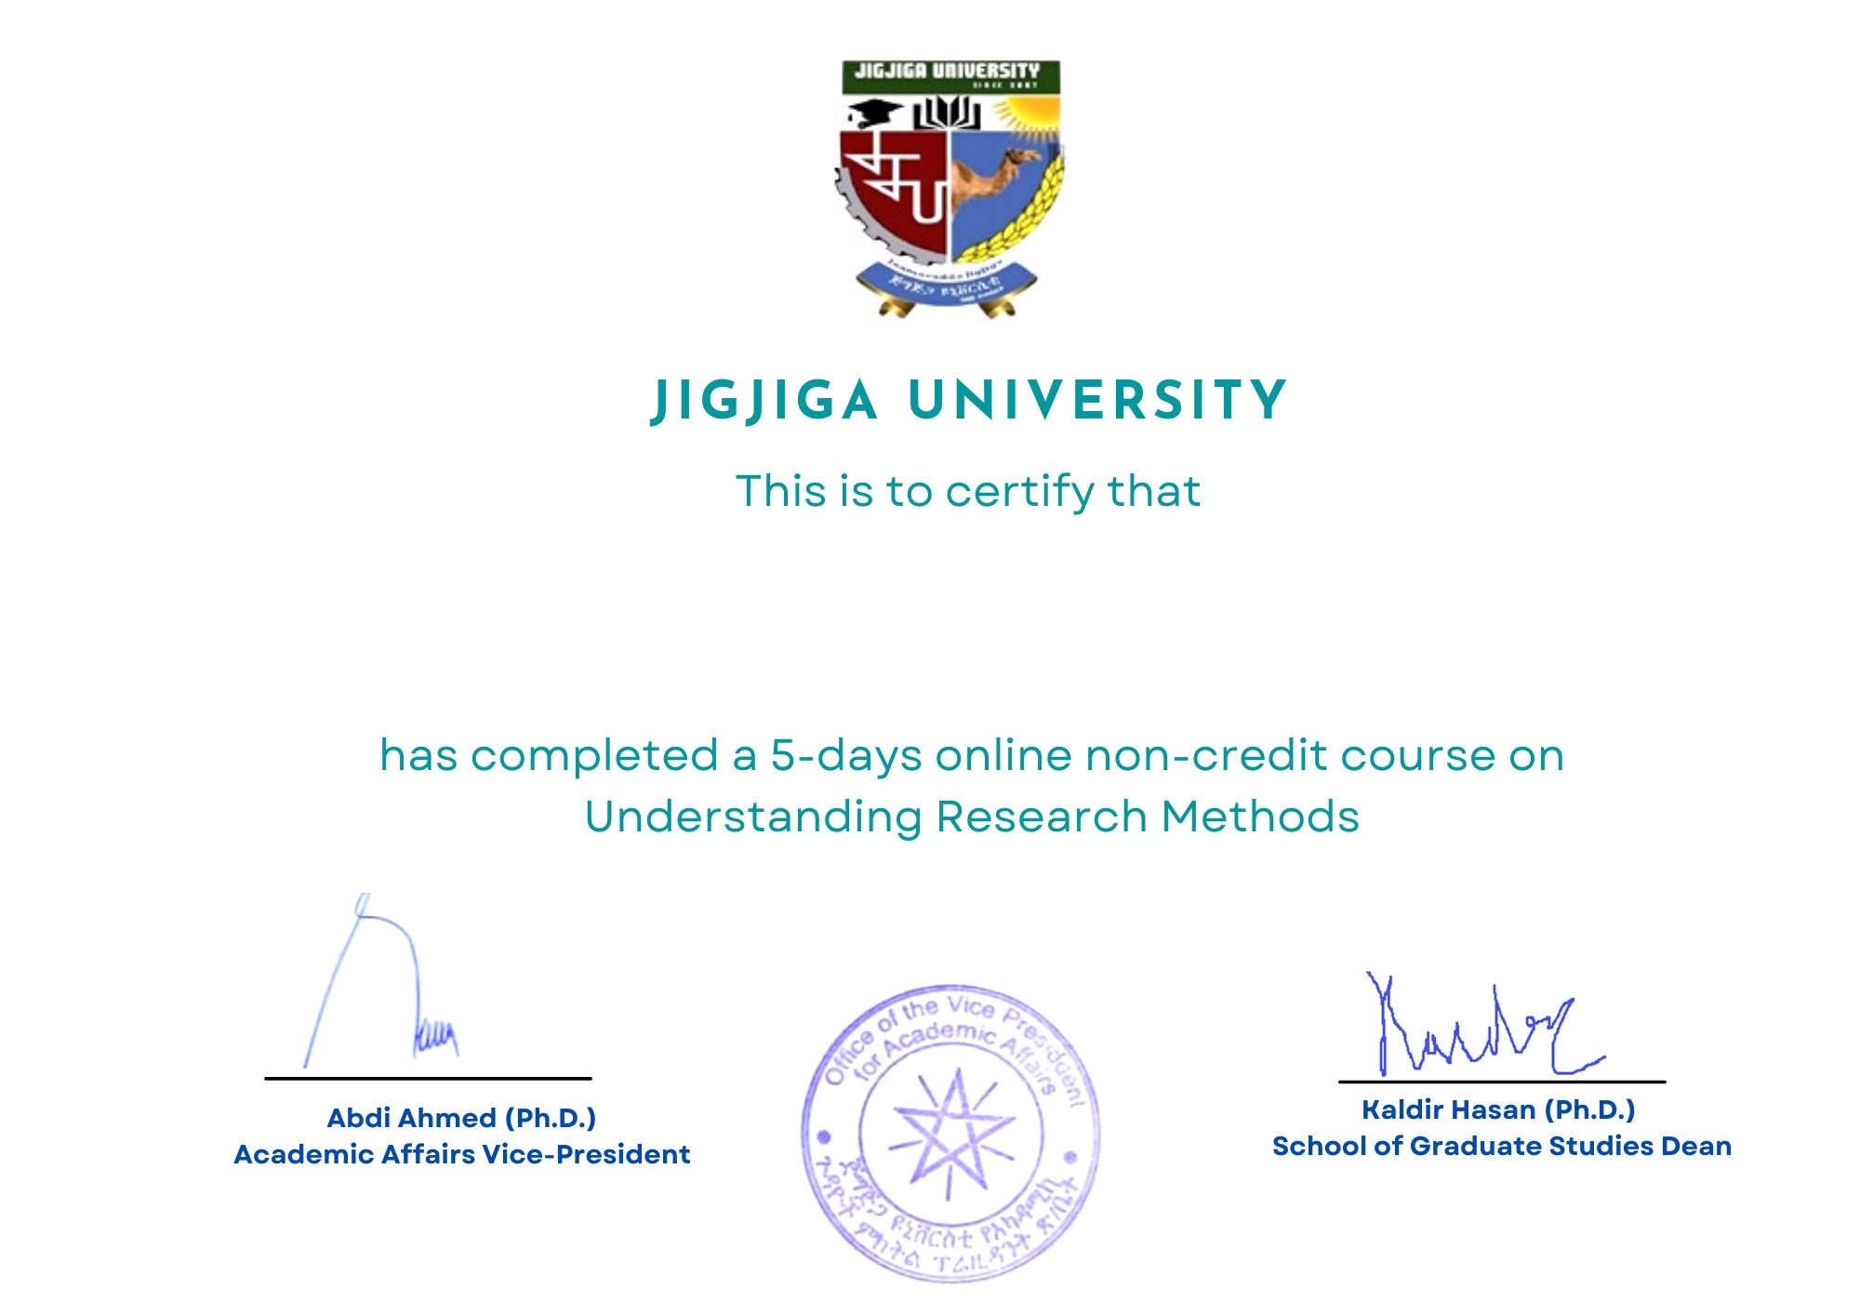

**TSEGAYE GEREMEW ABERA**